Chris Dechene



CS 305 Project Two
Practices for Secure Software Report

Table of Contents
CS 305 Project Two 1
Document Revision History 3
Client 3
Instructions 3
Developer 4
1. Algorithm Cipher 4
2. Certificate Generation 4
3. Deploy Cipher 4
4. Secure Communications 4
5. Secondary Testing 4
6. Functional Testing 5
7. Summary 5

Document Revision History

Version | Date | Author | Comments
1.0 | 2/14/2022 | Chris Dechene

Client



Instructions

Deliver this completed Practices for Secure Software Report documenting your process for writing secure communications and refactoring code that complies with software security testing protocols.
Respond to the steps outlined below and replace the bracketed text with your findings in your own words. If you choose to include images or supporting materials, be sure to insert them throughout.

Developer
Christopher Dechene

1. Algorithm Cipher
Determine an appropriate encryption algorithm cipher to deploy given the security vulnerabilities, justifying your reasoning. Be sure to address the following:

- Provide a brief, high-level overview of the encryption algorithm cipher.
- Discuss the hash functions and bit levels of the cipher.
- Explain the use of random numbers, symmetric vs non-symmetric keys, and so on.
- Describe the history and current state of encryption algorithms.

The encryption algorithm used in this program is the SHA-256 algorithm. Encryption algorithms are one-way hash functions that generate a random sequence of numbers or bits in order to create what is a message digest. Many algorithms use different bit levels to calculate the hash algorithm. In the case of SHA-256 this algorithm has a message size of 2^64 bits, a block size of 512 bits, a word size of 32 bits and a message digest size of 256 bits. This algorithm uses six logical functions in order to calcuate the bits used to code the data. This data is then processed and appears as random numbers and letters to disguise the data so it cannot be read. Artemis Financial's business deals with financial plans for retirement, savings, investments, and insurance with various customers in different sections of the world. It is crucial that this data is protected from the hands of thieves and hackers trying to access this information. The data being processed and calculated into message codes protects the data from being read and ensures security and protection of the customers financial information.

2. Certificate Generation
Generate appropriate self-signed certificates using the Java Keytool, which is used through the command line.

- To demonstrate that the keys were effectively generated, export your certificates (CER file) and submit a screenshot of the CER file below.

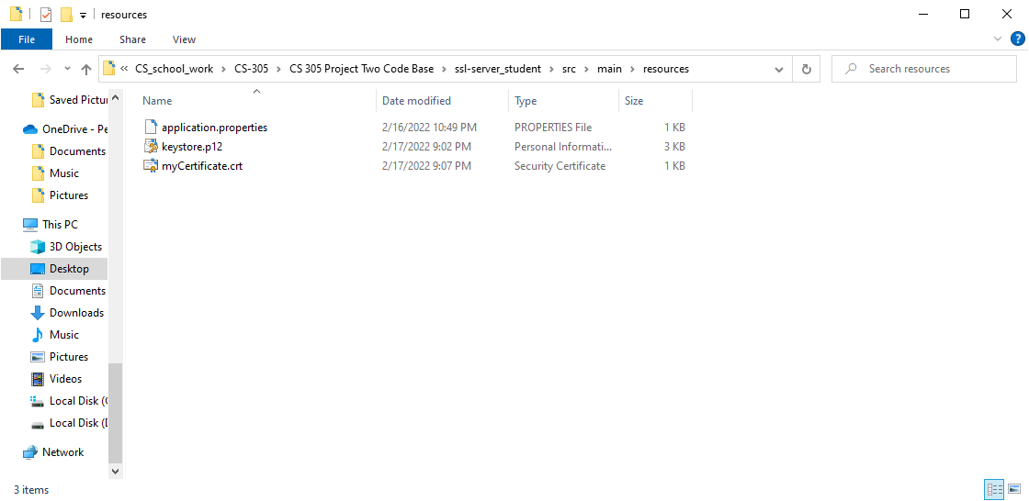
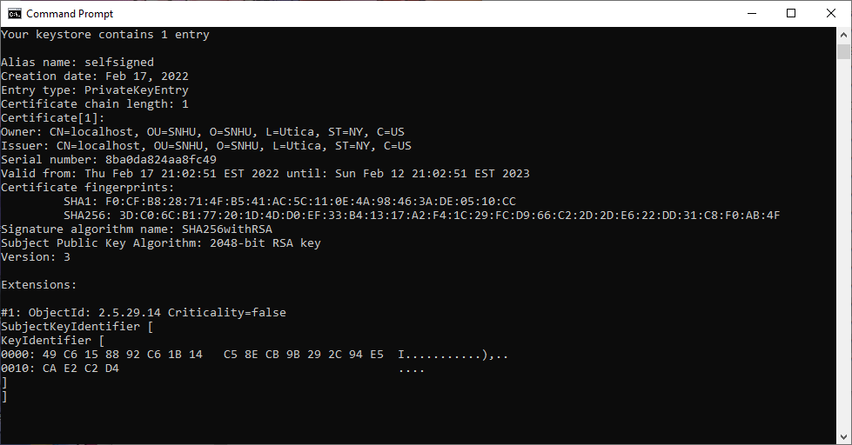

3. Deploy Cipher
Refactor the code and use security libraries to deploy and implement the encryption algorithm cipher to the software application. Verify this additional functionality with a checksum.

- Insert a screenshot below of the checksum verification. The screenshot must show your name and a unique data string that has been created.

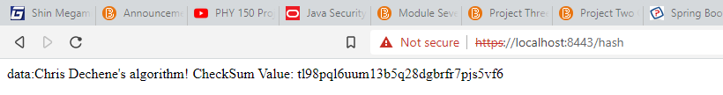

4. Secure Communications
Refactor the code to convert HTTP to the HTTPS protocol. Compile and run the refactored code to verify secure communication by typing https://localhost:8443/hash in a new browser window to demonstrate that the secure communication works successfully.

- Insert a screenshot below of the web browser that shows a secure webpage.

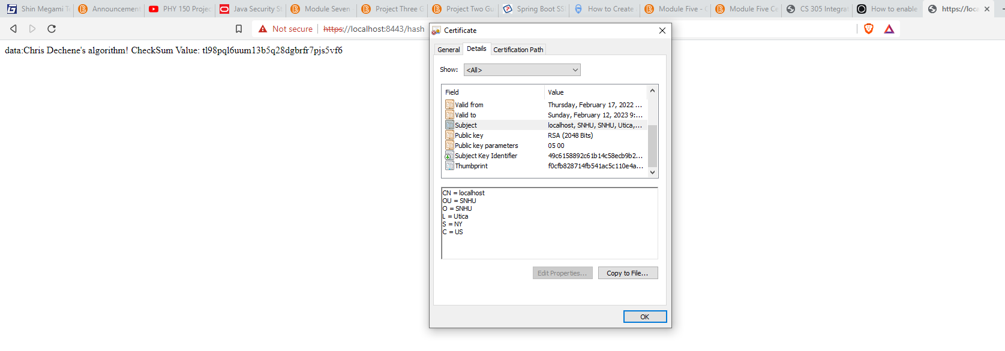

5. Secondary Testing
Complete a secondary static testing of the refactored code using the dependency check tool to ensure code complies with software security enhancements. You only need to focus on the code you have added as part of the refactoring. Complete the dependency check and review the output to ensure you did not introduce additional security vulnerabilities.

- Include the following below:
  - A screenshot of the refactored code executed without errors
  - A screenshot of the dependency check report
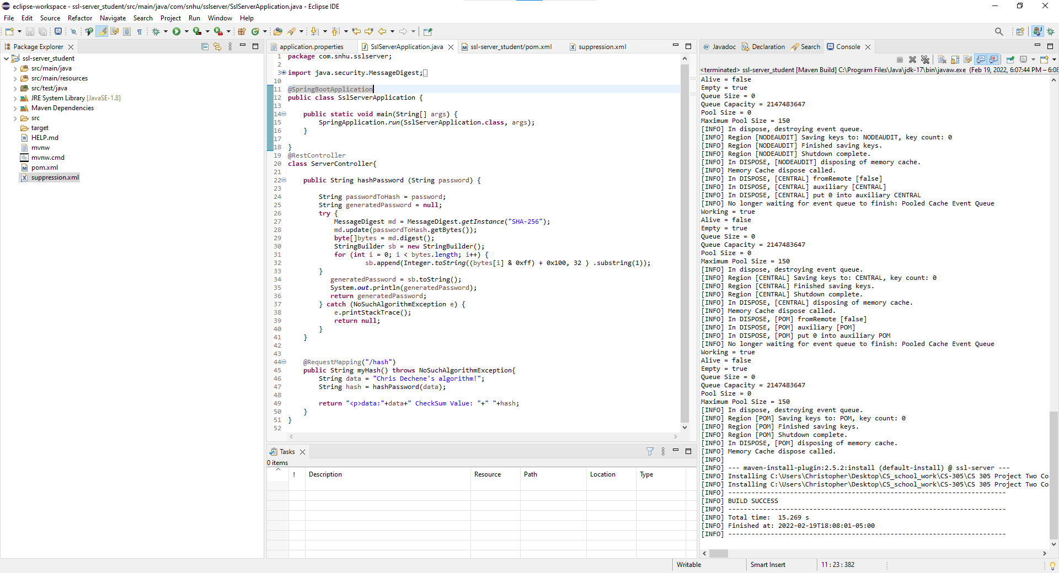

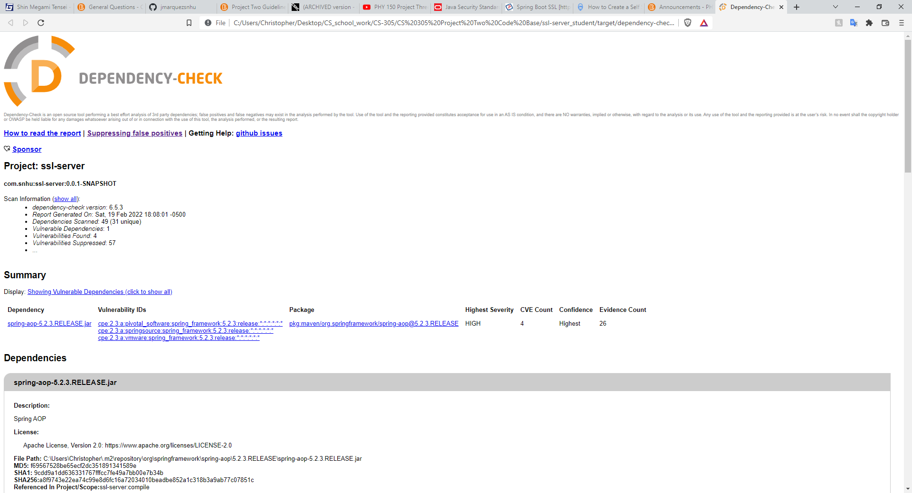

6. Functional Testing
Identify syntactical, logical, and security vulnerabilities for the software application by manually reviewing code.

- Complete this functional testing and include a screenshot below of the refactored code executed without errors.
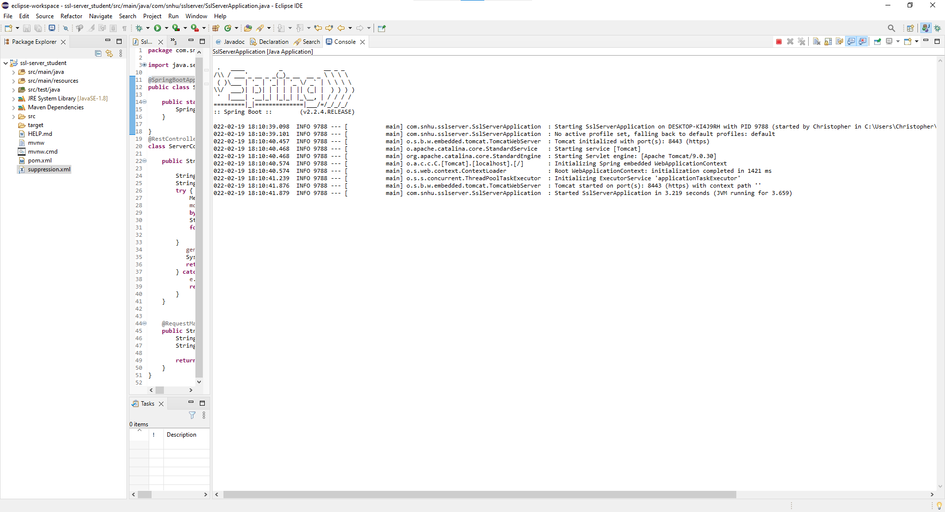

7. Summary
Discuss how the code has been refactored and how it complies with security testing protocols. Be sure to address the following:

- Refer to the Vulnerability Assessment Process Flow Diagram and highlight the areas of security that you addressed by refactoring the code.
- Discuss your process for adding layers of security to the software application and the value that security adds to the company’s overall wellbeing.
- Point out best practices for maintaining the current security of the software application to your customer.

In order to refactor the code to improve security it was requested to add a file verification step to their web application. This was accomplished through the addition of an algorithm cipher that was implemented by a checksum verification in the code. This area of security is part of Cryptography, by the use of encryption to protect the data this adds another level of security to protect the data from attacks to steal the information. The next layer of security is by the use of a generated self signed certificate to authenticate the website to people enterting the site so that they are aware that the site is secured. This also goes in hand with the addition of a class in the code to convert an HTTP connection to a more secure HTTPS protocol. This is to ensure a secure Client/Server connection which is another aspect of security to ensure the overall protection of the architecture. This is to prevent unauthorized access from outside parties to the server and to the clients accessing the server. Another aspect of the security of the architecture of the code is regarding Code Error. It is essential that the code compiles and runs without any errors. If the code contains any kind of errors then the program cannot function which leads to downtime which causes the business to be unable to operate their tasks. This downtime can cause Artemis Financial to lose profits and customers as a result. This can also create holes for attackers to breach through and possibly access any protected data so making sure the code is functional is essential. This also ties into making sure the code complies with software security enhancements. Checking for any kind of security vulnerabilities keeps a good eyue on the code so any updates to enchance the security and protect any holes can be aknowledged then completed. These several practices go a long way to creating code and a server that is layered with security to protect the vital data of the customers who go to use Artemis Financial's services to keep valuable information safe from any attempts by hackers who would try to take the information for their own.

